Základy kvantové a nelineární optiky NOOE027
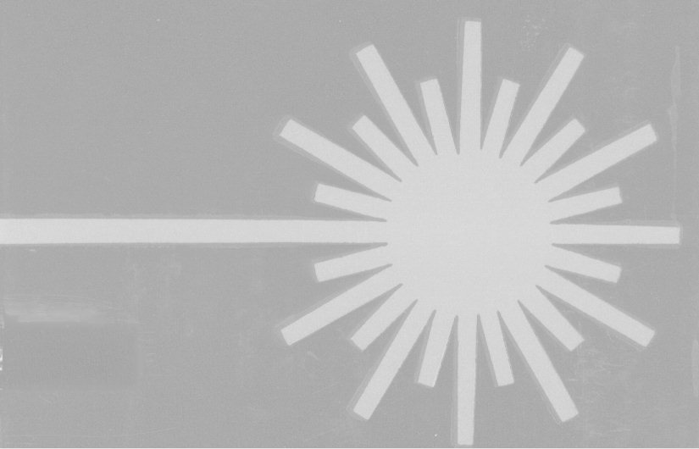
(ZS – Základy laserové fyziky)

ZS 2021-2022, (3/1), P. Malý
http://physics.mff.cuni.cz/kchfo/ooe/lasery

1. Light-matter interaction

Classical description. Einstein approach. Semiclassical approach. Einstein coefficients, Rabi oscilations. Line-shape function.

2. Laser rate equations
Formulation of the equations. Laser oscillator. Laser threshold. Optical gain, gain saturation.

3. Optical resonators
Geometrical optics of resonators. Stability of resonator. Boyd-Koleglnik diagram. Wave theory of resonators. Gaussian beam. Laser modes.

4. Laser dynamics
Cw laser. Optimum output coupling. Relaxation oscillations. Q-switching. Mode-locking. Femtosecond lasers.

5. Semiclassical laser equations

Formulation of semiclassical equations. Maxwell-Bloch equations. Chaos in laser dynamics.

6. Selected types of lasers

Gas lasers. Solid state lasers-Semiconductor lasers. Dye lasers. Free electron lasers.

O. Svelto: Principles of Lasers, Plenum, New York 1982, Springer-Verlag, New York 2010.
A. E. Siegman: Lasers, University Science Books, Mill Valley, Ca. 1986.
B. E. A. Saleh, M. C. Teich: Základy fotoniky, Čes. překlad Matfyzpress 1991.
M. Sargent III, M.O.Scully, W.E.Lamb,Jr.: Laser Physics, Addison-Wesley, Reading, 1974.
H. Haken: Light, vol.1 (Waves, Photons, Atoms), North-Holland, Amsterdam 1981.
H. Haken: Light, vol.2 (Laser Light Dynamics), North-Holland, Amsterdam 1985.
W. Koechner: Solid-State Laser Engineering, Springer-Verlag, New York 1976.
A. Yariv: Quantum Electronics, J. Wiley & Sons , New York 1975.

